EXPERIMENT NO : 03

AIM : To practice/execute shell programs and parameterized Java programs using Jenkins

THEORY :

Jenkins is an open-source server that is written entirely in Java. It lets you execute a series of actions to achieve the continuous integration process, that too in an automated fashion.

This CI server runs in servlet containers such as Apache Tomcat. Jenkins facilitates [continuous integration and continuous delivery](https://www.lambdatest.com/blog/what-is-continuous-integration-and-continuous-delivery/" \t "_blank) in software projects by automating parts related to build, test, and deployment. This makes it easy for developers to continuously work on the betterment of the product by integrating changes to the project.

Jenkins automates the software builds in a continuous manner and lets the developers know about the errors at an early stage. A strong Jenkins community is one of the prime reasons for its popularity. Jenkins is not only extensible but also has a thriving plugin ecosystem.

Some of the possible steps that can be performed using Jenkins are:

* Software build using build systems such as Gradle, Maven, and more.
* Automation testing using test frameworks such as Nose2, PyTest, Robot, Selenium, and more.

TO PRACTISE/EXECUTE SHELL PROGRAMS USING JENKINS

Step 1 : Click on Create new jobs

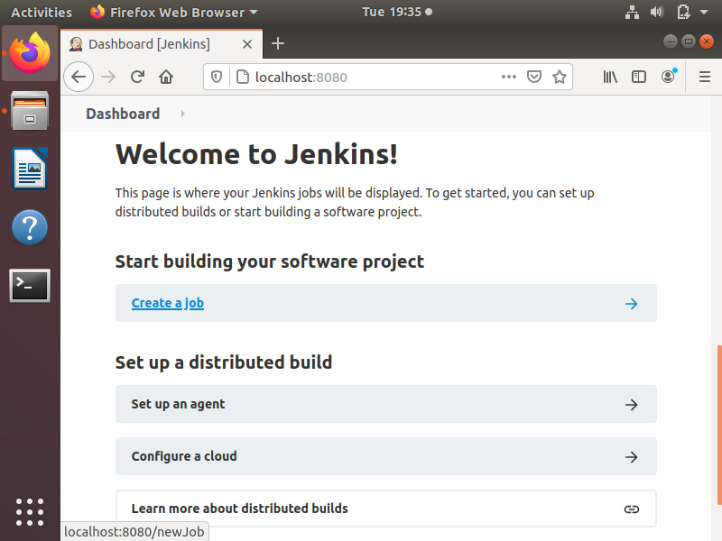

Step 2 : Give a name to project as “P1”, select Option “Free style project” and click on OK button

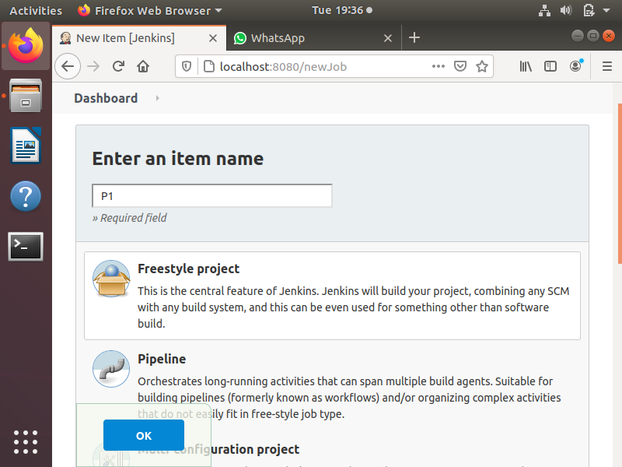

Step 3 : To run simple shell scripts on Jenkins click on Build option select the Execute script from dropdown menu

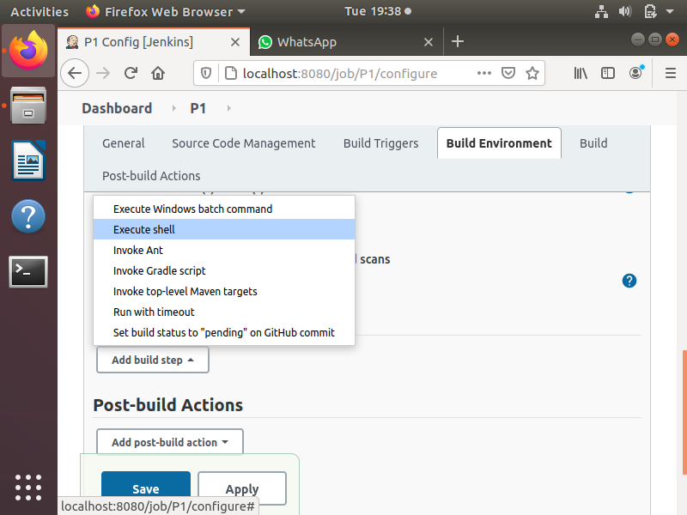

Step 4 : Write a simple shell command and click on apply followed by save button

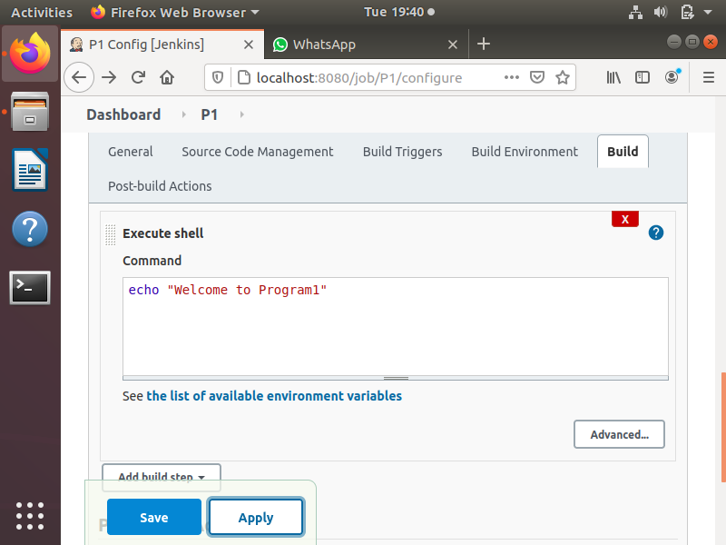

Step 5 : Click on first build “1” followed by console output to see the output

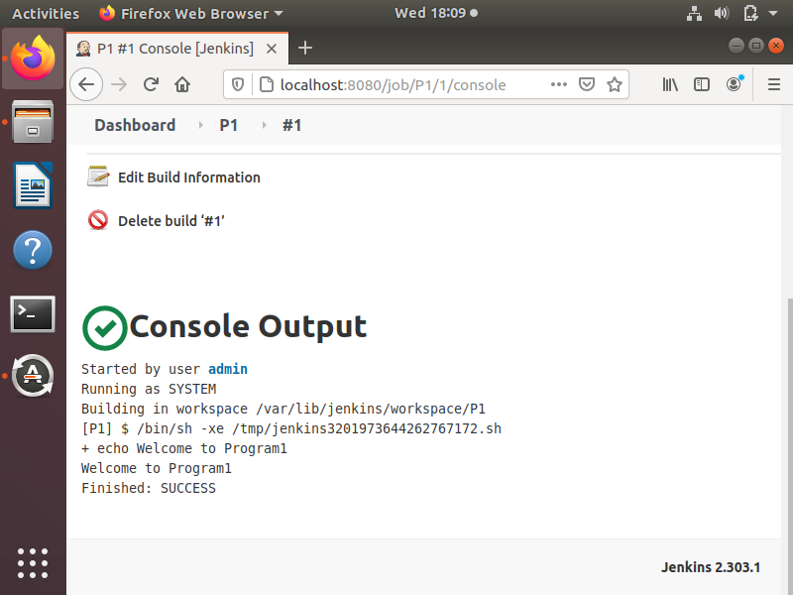

TO PRACTISE/EXECUTE PARAMETERISED JAVA PROGRAMS USING JENKINS

Step 1 : Create a freestyle project P2 in Jenkins

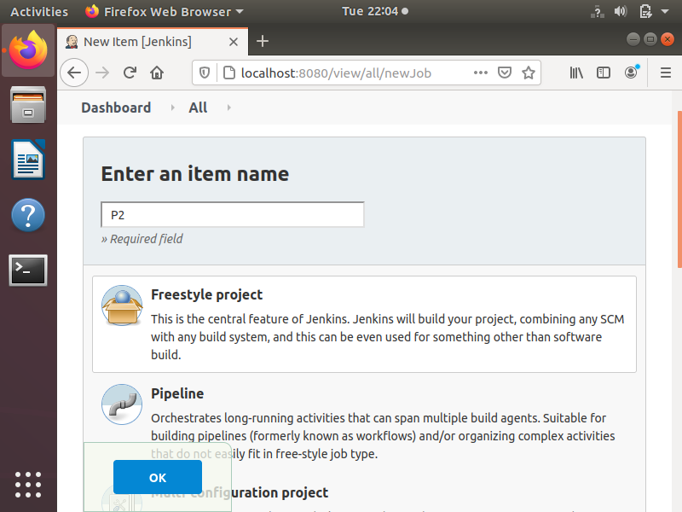

Step 2 : Click on general menu and select option this project is parameterize. Select String parameter and specify name as “First-Name”

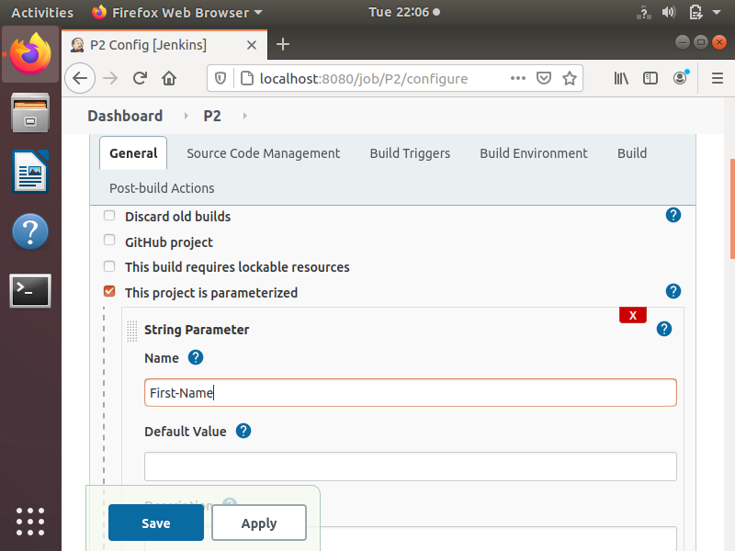

Step 3 : Click on add parameter and select choice parameter. Take second parameter as choice parameter

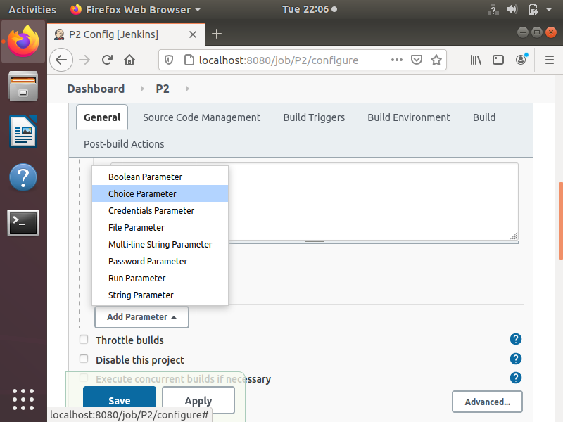

Step 4 : Specify name as “City” and add the choices in each line

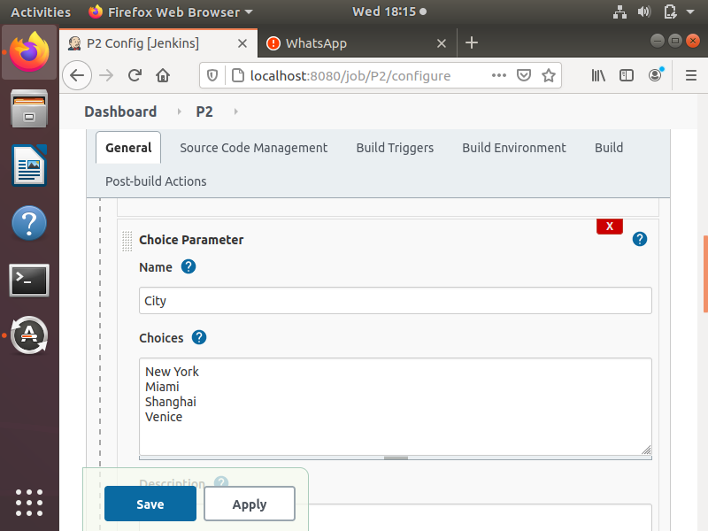

Step 5 : Click on build with parameters and specify the values

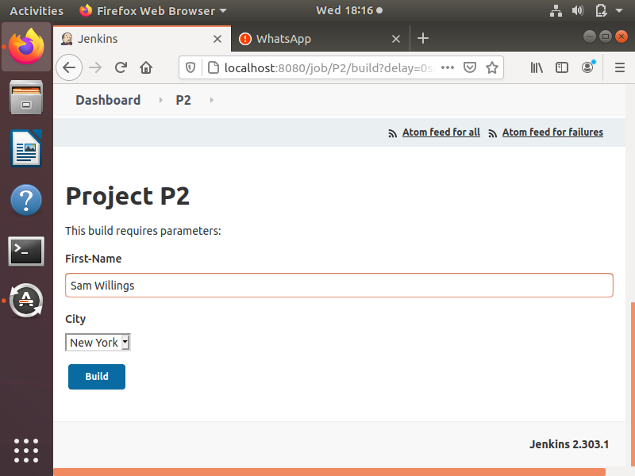

CONCLUSION : Hence we can conclude that we have learned and implemented shell programs and parametrized Java programs using Jenkins.